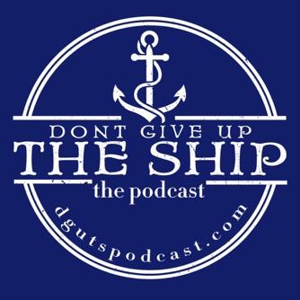
Don’t Give Up The Ship Podcast
Guest Interview Instructions

- Plug in whatever device you intend to use to record with (USB microphone, headphones, gamer headset, airpods, etc.) BEFORE YOU CLICK THE ZENCASTR LINK. Make sure your computer recognizes it by opening your computer’s audio settings.

For Mac – Click the “Launch Pad” icon (rocket ship), then open “Settings” (grey gear). Finally, click “Sound” (grey speaker) and verify your device is selected for both input (microphone) and output (headphones). If you’re using a gaming headset, airpods or a setup where your headphones are plugged into a monitor jack for your microphone, they will be the same device.
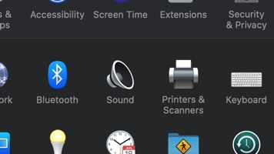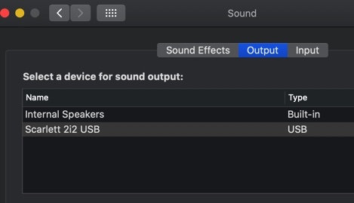
For Windows 10 – Go to the “Start” menu, then open “Settings”, “System”, “Sound”, then “Sound Control Panel”. Then verify your device is selected for both input (microphone) and output (headphones). If you’re using a gaming headset, airpods or a setup where your headphones are plugged into a monitor jack for your microphone, they will be the same device.
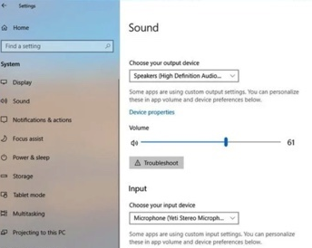
- Next, open the Zencastr email invite from DGUTS. Right click the “Start Recording” button and select “Copy Link Address”. Then open a tab in your chosen browser (must use Google Chrome or Firefox for compatibility) and right click the address line, selecting “Paste and Go”.
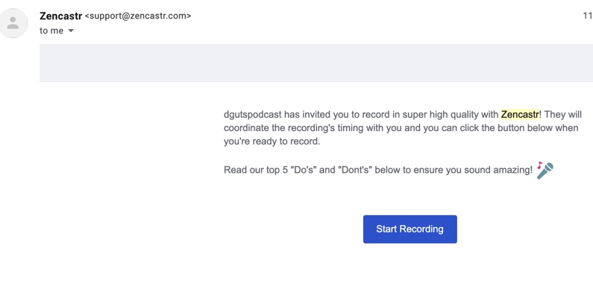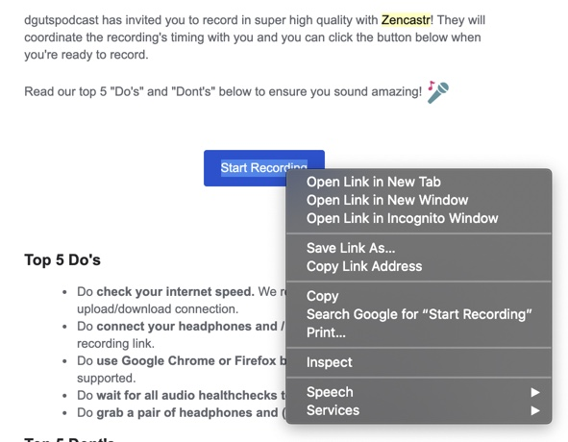
- Once Zencastr is opened, you should see “DGUTSPODCAST” also on the screen and under your name, you will see “health checks” being run, to ensure Zencastr recognizes your devices and that everything is ready to record. If there are issues, look at the chat box below your name. DGUTS will provide guidance and we will troubleshoot from there.

- Once we are able to talk and everything is working properly, we’ll discuss some things and then get rolling! You don’t have to do anything on your end once we’re ready to record except talk and listen. Once complete, you will see your audio uploading with a % status. PLEASE DO NOT CLOSE YOUR BROWSER UNTIL THIS IS COMPLETE! You do not have to stay on the microphone, just don’t close the window.

- Additional Information: for the actual podcast, there are a few Frequently Asked Questions I’ll address here but feel free to ask anything you’re unsure of before we start recording.
  - Please try not to curse. It’s fine if you slip up, I can edit it out or bleep it out but it adds post production time each time we do (I slip too), just please make an effort.
  - Do not use identifying information unless you’re completely comfortable. Again, if you slip, I can edit but it’s best to stay as vague as possible with things like sea stories to ensure no one is upset by a story they perceived to be private being shared publicly.
  - If we do record something that is sensitive, private or you just decide later you’re uncomfortable sharing publicly, just let me know and we’ll edit it out. It’s completely fine, I will not publish anything that any guest decides they’re uncomfortable with after recording.
  - Feel free to go wherever you want with the conversation. During interviews, I generally come in with basic ideas of what I would like to discuss but am often (pleasantly) surprised by guest’s stories, answers and find us going somewhere I did not expect. THAT IS FINE! I’ll discuss whatever you want for as long as you want, no time limit or subject limits on my end. If we go off on a tangent that doesn’t make sense or is silly, that’s what editing is for so don’t sweat it. I’ll guide the conversation with the questions I come in with but often develop questions based on your stories and responses as we go.
  - When I ask for your bio/experience at the beginning of the episode, again, only share what you’re comfortable with. Oftentimes junior Sailors are concerned that someone at their command may be unhappy with them participating or with what they share. So, if you’re even a little concerned, just stay as vague as you need to. I won’t push you for more.
  - I’m generally about a month ahead on content, so the episode will usually release about one month after recording. I’ll try to give you an exact date based on my episode schedule and will also happily provide the image I use for social media if you desire to share it. Also, if you have your own platform of some kind (i.e. a podcast) I’m happy to provide the raw audio file for use on your platform. Just let me know.
  - If you have ANY OTHER QUESTIONS, do not hesitate to ask them! Either before we record on Zencastr or through any of the contact info below:
      - Email: dontgiveuptheshippodcast@gmail.com
      - Facebook Messanger: Don’t Give Up The Ship Podcast
      - Instagram: @dgutspodcast

